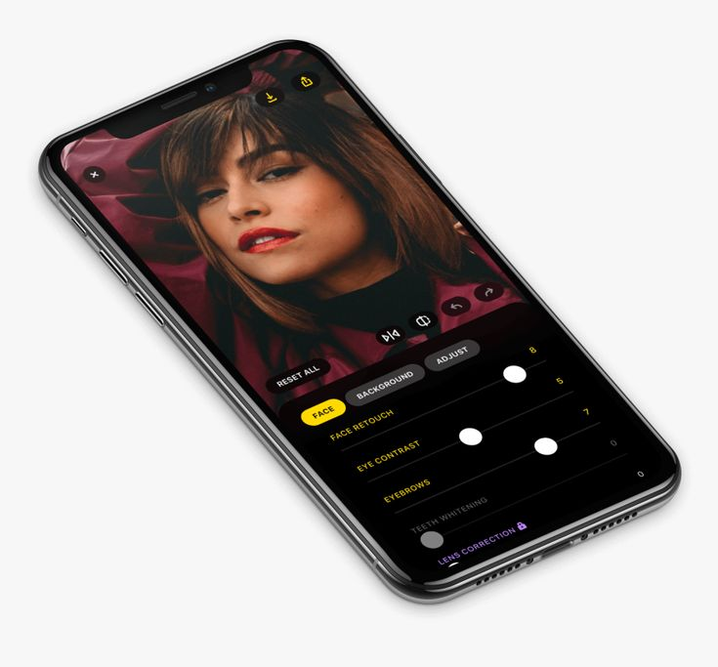

TITLE: MARKETING INITIATIVE PROPOSAL FOR GREENGLOBE_GADGET

DATE: 23TH OF SEPTEMBER 2024

PREPARED BY: CHIEMELA IZUWA

TABLE OF CONTENTS

1. Introduction 4
2. Objectives 6
3. Target Audience 8
4. key Strategies 9
Sustainabitly Campaign 13
Social Media Engagement 15
5. Product Overview 20
Phone Models 22
Pricing 26

7. Promotional Offers 29
8. How to Order 31

9. Contact Information 33
INTRODUCTION

Welcome to Greenglobe where technology meets innovation! As a leading provider of smartphones and laptops, we are dedicated to delivering the latest
Devices that enhance your digital lifestyle.
Explore our competitive prices, special offers, and personalized service today!
This proposal outlines a marketing initiative to enhance brand awareness and drive sales.

OBJECTIVE

Increase brand visibility and recognition.
Drive traffic to the website and social media platforms.
Boost sales by 20% over the next six months.
Promote sustainability and eco-friendly practices, such as recycling programs

TARGET AUDIENCE

Environmentally conscious consumers aged 18-45.
Tech-savvy individuals interested in innovative phone features.
Customers looking for sustainable alternatives in electronic devices.

KEY STRATEGIES

Sustainability Campaign
Highlight eco-friendly materials and manufacturing processes in marketing materials.
Partner with environmental organizations for joint promotions.
Launch a “Recycle Your Old Phone” initiative to encourage sustainable disposal.

SOCIAL MEDIA ENGAGEMENT

- Create interactive content such as polls, quizzes, and user-generated content contests.
- Share educational posts about sustainability and the benefits of eco-friendly technology.
- Collaborate with influencers who advocate for sustainability.

PRODUCT OVERVIEW

Phone Models
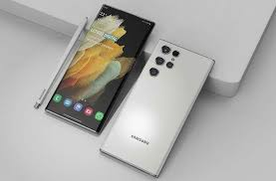
Samsung s24 Ultra
Price: $599
Selfie Camera
12mp
Main Camera
Triple 200MP/ 50MP / 10MP
Battery
5000mAh

Phone Models


iPhone 12 pro max
Price: $699
Selfie Camera
12mp
Main Camera
Triple 12MP/ 12MP / 12MP12MP
Battery
3687mAh

PROMOTIONAL OFFERS

Launch discount: 15% off for first-time buyers.
Referral program: $50 credit for each successful referral.
Seasonal promotions during Earth Day and tech events.

HOW TO ORDER

website at www.greenglobe-gadgets.com.
Choose your model and customize your order.
Complete the checkout process with secure payment options.

CONTACT INFORMATION

Customer Service: support@greenglobe-gadgets.com
Phone: 08146469277
Follow us on social media: Instagram, Facebook, Twitter @greenglobe_gadgets

